Answer the following questions:

1. Describe the significance of the global variable index. How is indexing used with lists in this app?

**Answer**

|  |
| --- |
| **The global variable index allows for the app to consistently call the same index number.** |

2. Describe how parallel lists were used in this app. Why was the parallel structure of the lists necessary?

**Answer**

|  |
| --- |
| **The parallel list structure was necessary because It allowed for the index to pull the correct answers, pictures, and questions from the lists. If it was not a parallel list the answers, questions, and pictures would be much harder to get the correct combinations of these three things.** |

3. Include **screenshots** of your code for exercises 2 and 3 from the *Enhancements* section.

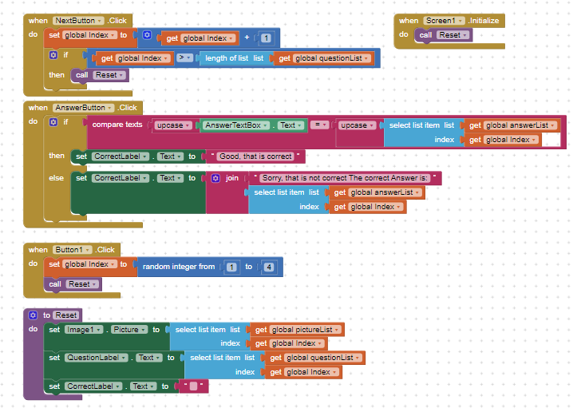

4. Include a **screenshot** of the code that added your extra question (exercise 4). Explain why the code for the buttons worked without any changes after the addition of the extra question.  
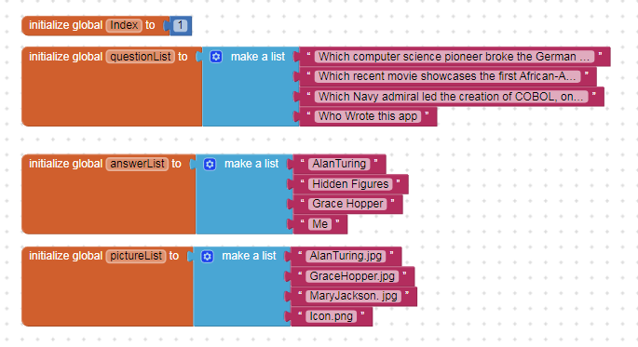  
**Answer**

|  |
| --- |
| **The code still worked because the lists are parallel and there is no set limit on what indexes that the app can choose when showing questions.** |